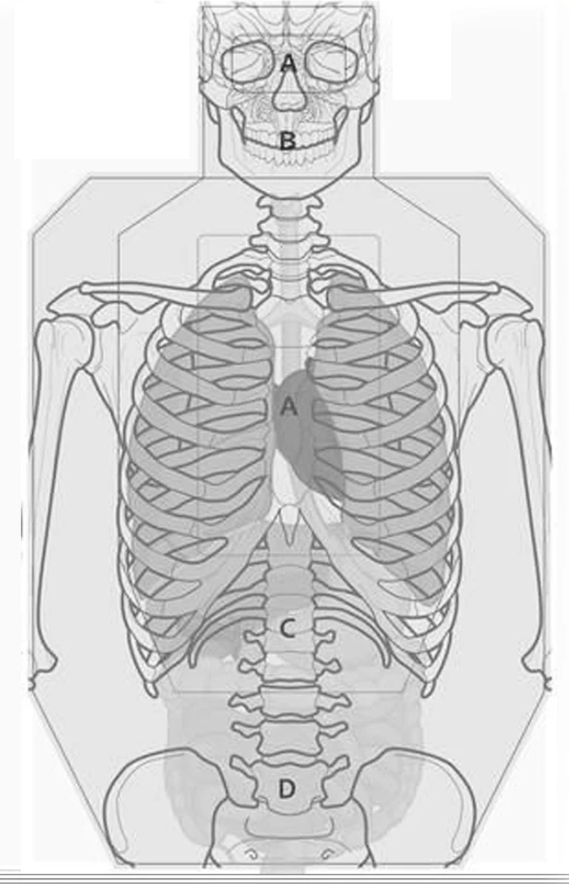
Target 2 Pistol/Revolver - - - Rounds: _____ Time: _______
Distance & Par Time (Goal): Circle your choice:
3 yds (1/2 sec) / 5 yds (1 sec) / 7 yds (1.5 sec)
Distance : 10 yds (No Time)
Name: __________________________________________ Month: __________

